

**Sample Email #2 From Table Captains to Network**

**Send May 10-16**

Subj: COVID and gun violence

Hi [enter name here],

I hope you’re taking care of yourself and your loved ones.

I wanted to follow up to see whether you’ve had the chance to check out the Alliance for Gun Responsibility? If you haven’t, you can learn more about them here:

<https://gunresponsibility.org/>

We are, of course, in uncharted waters right now. As so many families face health challenges and financial hardship, there are countless causes worthy of our support and I believe the fight against gun violence is among the most important.

The Alliance put together an infographic illustrating how COVID-19 threatens to exacerbate gun violence. Check it out.

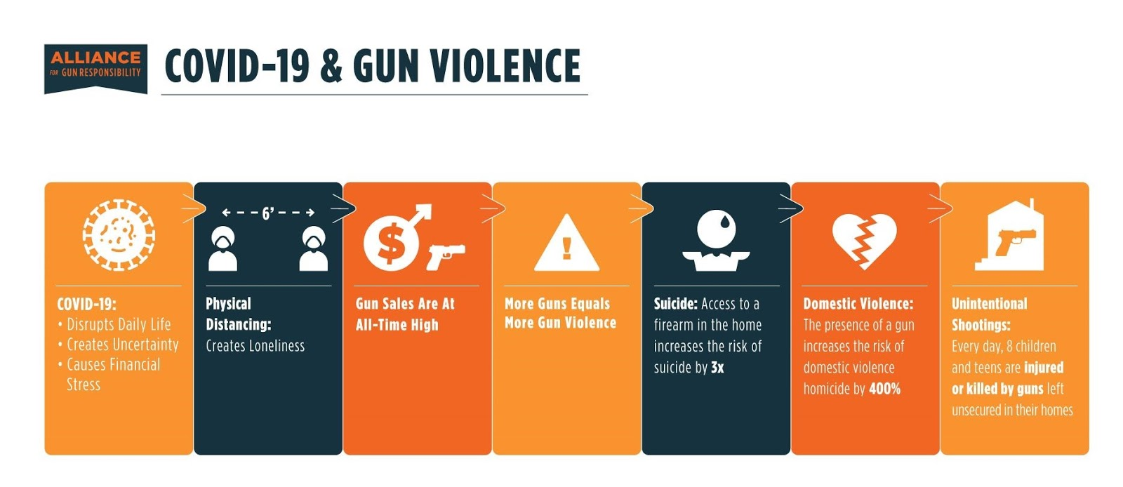

The most impactful thing you can do right now to prevent gun violence is make a donation to the Alliance for Gun Responsibility. I have committed to helping the Alliance meet their $1M fundraising goal by May 31st. Will you please join me in supporting this lifesaving work?

<https://secure.actblue.com/donate/agrluncheon>

Instead of their traditional luncheon, the Alliance is hosting a panel discussion on June 1st that will address the intersection of COVID and gun violence. You can RSVP for that here:

<https://us02web.zoom.us/webinar/register/WN_EOpZMItbQ9WC3mR3f5zZaA>

Thank you for helping the Alliance prove that gun violence is preventable.

Best,